**Business Proposal: CampusTrail — All-in-One Campus Travel Hub**

**Prepared for: E-commerce (Term IV), IIM Kashipur**Prepared by: CampusTrail Project Team  
Date: September 07, 2025  
Version: v3.2 (Vertical Diagrams Edition)

# Section 2 — Product/Service Information: Vertical Diagrams

## 2.3.0 Generic Rental Flow

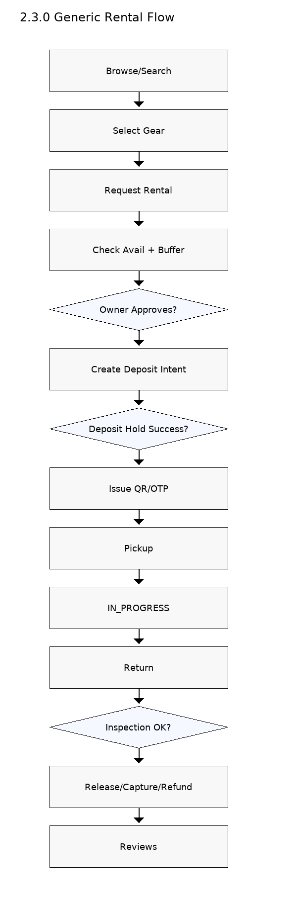

SVG: **/mnt/data/2.3.0_Generic_Rental_Flow.svg**

## 2.3.1 Fest DSLR Rental

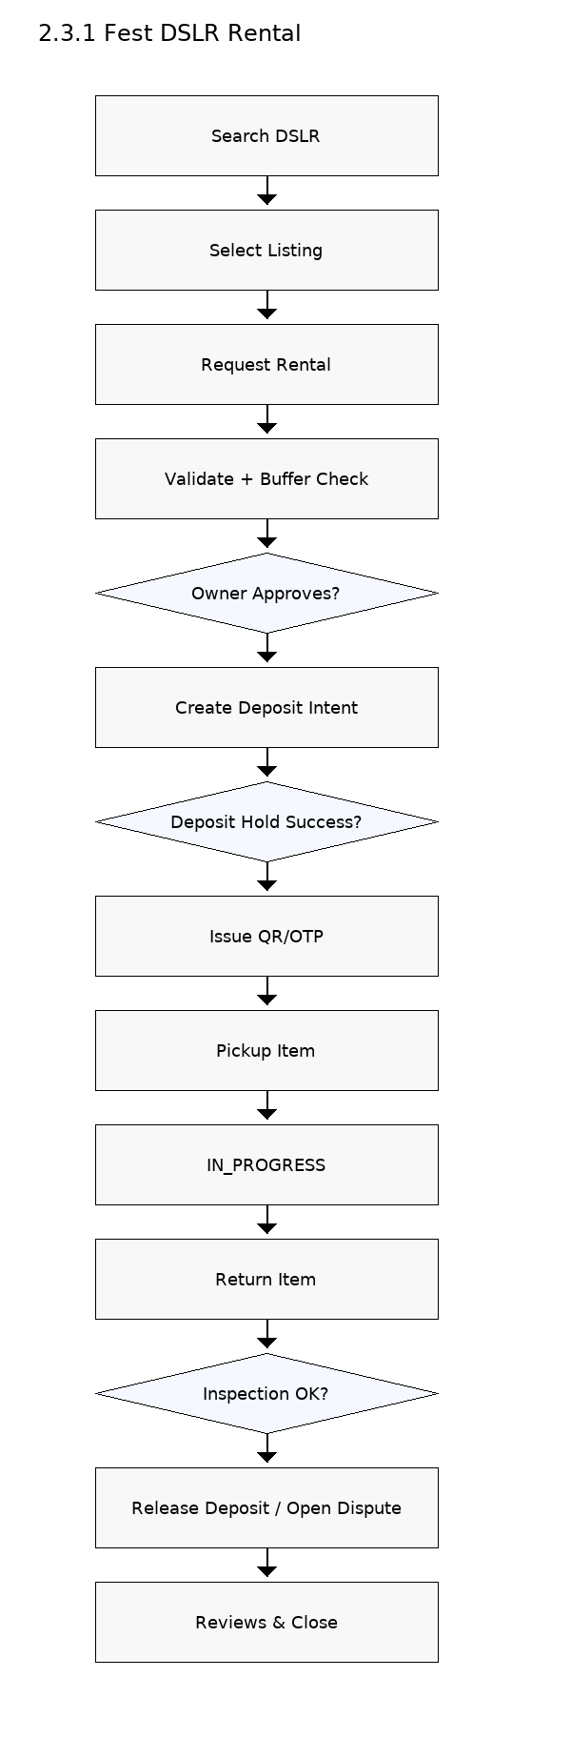

SVG: **/mnt/data/2.3.1_Fest_DSLR_Rental.svg**

## 2.3.2 Trekking Group Formation

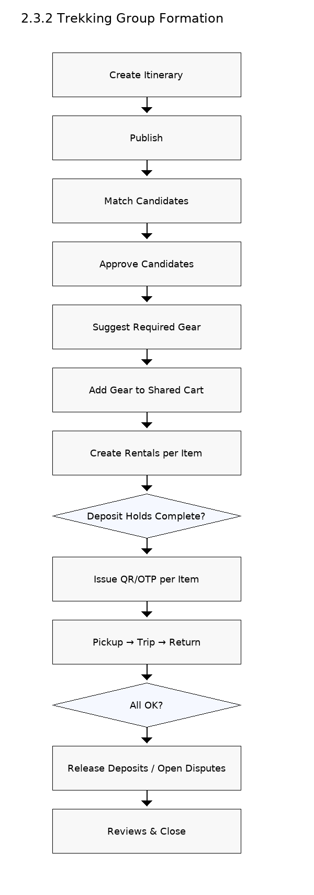

SVG: **/mnt/data/2.3.2_Trekking_Group_Formation.svg**

## 2.3.3 Last Minute Tripod

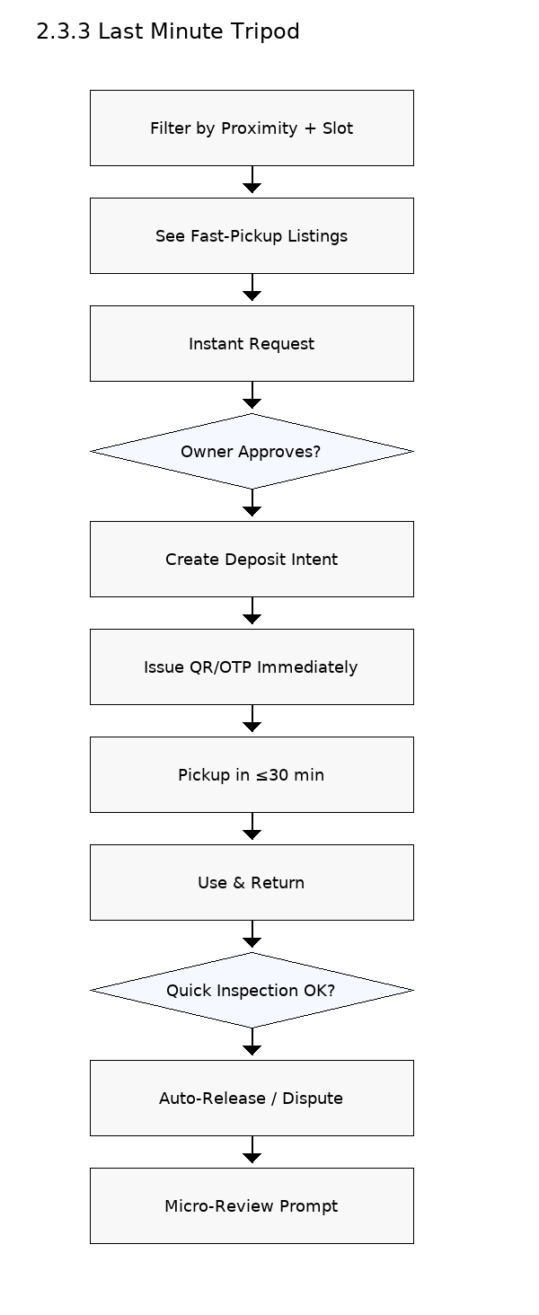

SVG: **/mnt/data/2.3.3_Last_Minute_Tripod.svg**

## 2.3.4 Club Gear Pool

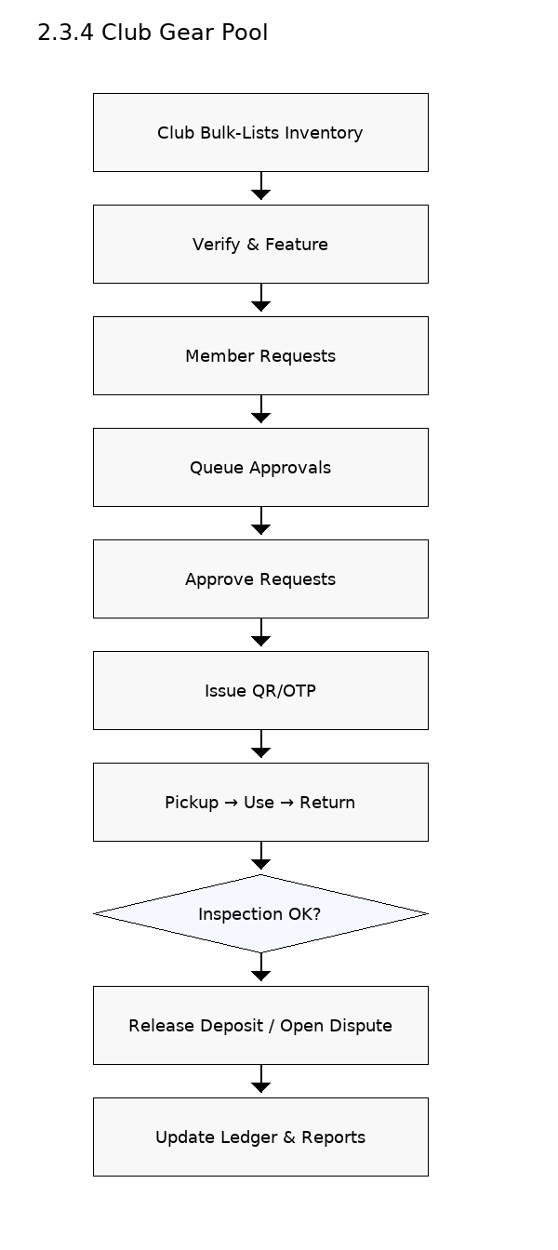

SVG: **/mnt/data/2.3.4_Club_Gear_Pool.svg**

## 2.3.5 Damage Dispute Resolution

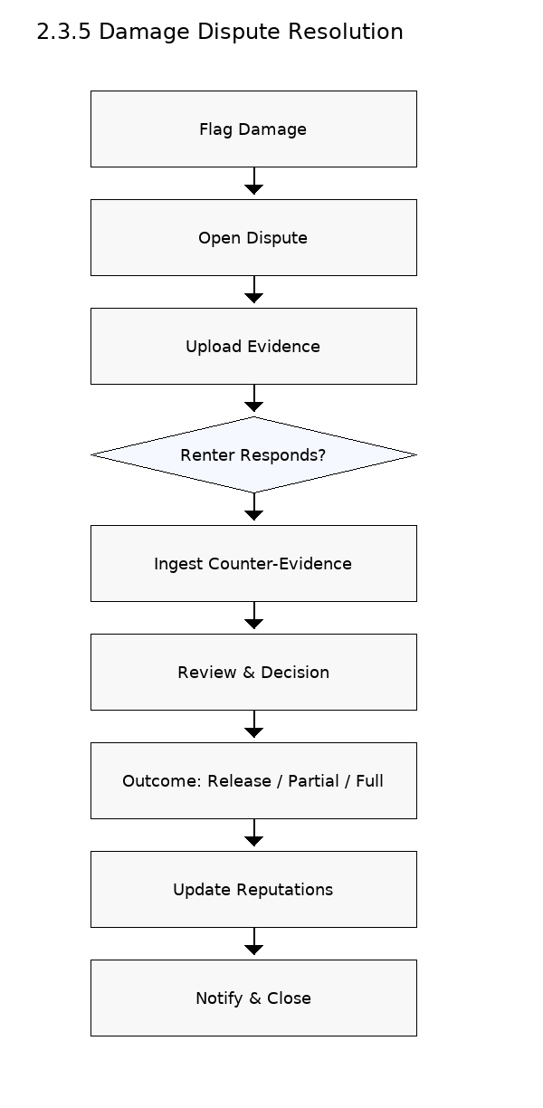

SVG: **/mnt/data/2.3.5_Damage_Dispute_Resolution.svg**

## 2.4.1 Deposit Flow

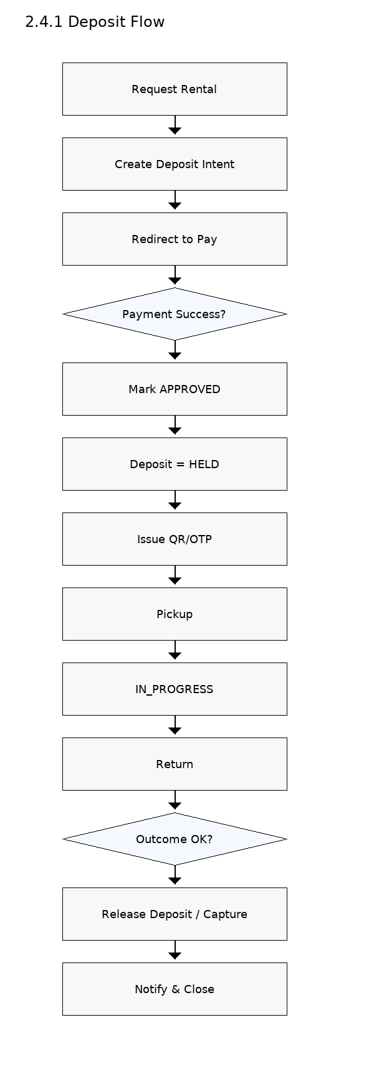

SVG: **/mnt/data/2.4.1_Deposit_Flow.svg**

## 2.4.2 Dispute Resolution Flow

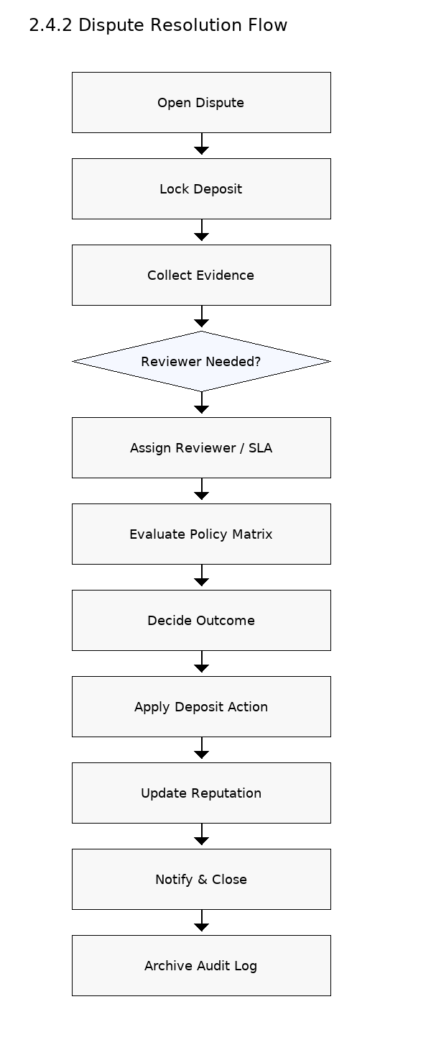

SVG: **/mnt/data/2.4.2_Dispute_Resolution_Flow.svg**

# Appendix — Mermaid Source (Top-to-Bottom)

All diagrams are also provided as Mermaid code blocks in: **/mnt/data/CampusTrail_Diagrams_Mermaid.md**